

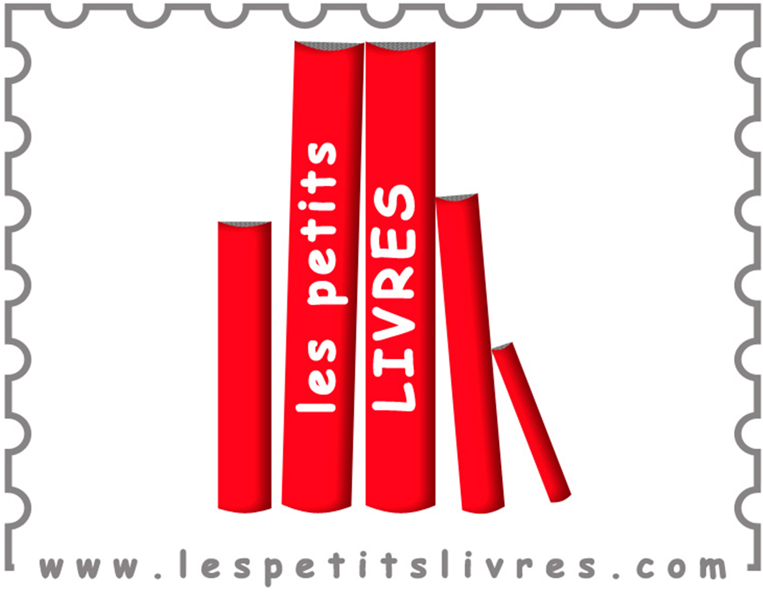

Special Offer from

Les Petits Livres

Renting French books has never been so easy...

save time, money and space!

For an all-inclusive annual fee of $100, your family will receive

5 sets of 6 books throughout EFGS schoolyear.

Easy as... The first shipment will be mailed to your house in October. Return the books as soon as you are ready and you will receive a new set, for a maximum of 5 sets all together. All books will have to be returned by June 9th, 2018.

NEW this year...You can add a 9-month subscription to **Storyplay'r**, a digital library of children ebooks in French, at the discounted price of $33.75.

Create a wishlist from over 3,000 quality books in French...

Your can choose any books in the age category that best suits your child, including Bandes Dessinées*. Books, as available, will be selected from your wish list. If a title from your wishlist is unavailable at time of shipment, a substitution in the same age category will be made by Les Petits Livres.

or not...

If you prefer, you can have Les Petits Livres make all selections for you. In that case, you just have to wait for the books to arrive!

*\*each shipment will include a maximum of 2 Bandes Dessinées.*

ORDER FORM - To be completed and returned by email to info@efgseattle.org before October 8, 2017

Yes, I would like to benefit from this special offer and I select the following plan:

6 books at a time- 5 times a year  6 books at a time- 5 times a year with Storyplayr

$100 $133.75

|  |  |  |
| --- | --- | --- |
| 1 - Child's Name: | 2- Child's Name: | 3- Child's Name: |
| Date of Birth (MM/DD/YY): | Date of Birth (MM/DD/YY): | Date of Birth (MM/DD/YY): |

**I understand that I have to make the payment to EFGS to finalize this order ($100 or $133.75 for 2017-2018 school year).** I will receive a Paypal invoice email and pay it as soon as possible and before October 8 to complete my order.

Contact email:      Contact Name (First and Last):

I agree to have EFGS share with and forward the above information to Les Petits Livres for the purpose of setting me up for this library program. Les Petits Livres will then contact me (at the email provided above) with instructions on:

- how to register,

- how to place an order to provide them with a mailing address and to select the age group, child's gender and book type for each of the six books you would like to receive

- how to create wish list, and

- any additional information that may be required for set-up